WRST Caribou Monitoring Database Application

**Table of contents**

About 3

Overview of interface 7

Data entry: Survey data 7

Data entry: Capture data 12

Quality control 12

Appendix A: Data definitions 14

Results 17

**About**

# Caribou Monitoring in Wrangell St. Elias National Park and Preserve

Caribou is one of the 'Vital Signs' monitored within Wrangell-St. Elias National Park by the National Park Service Central Alaska Inventory and Monitoring Network. Caribou occur in all three Central Alaska Network parklands and are found in four separate herds: Denali, Mentasta, Chisana, and Fortymile. In the context of the monitoring program, they represent the grazers of the trophic levels, as do Dall’s sheep and small mammals.

While caribou represent the role of a grazing animal in the conceptual model of the network program, they are also of interest for monitoring for several other reasons. First, three of the four herds found in Central Alaska parklands have experienced significant recent declines and one of those, the Fortymile herd, has now reversed it’s trend and is increasing. Second, subsistence harvest on two herds (Chisana and Mentasta) has been curtailed due to conservation concerns; providing the opportunity for subsistence activities is a directive for NPS lands in Alaska. Third, one herd (the Nelchina) is the subject of intensive interagency management, including the control of predators. Fourth, one herd (the Chisana) that straddles the U.S.-Canada border is the subject of an international cooperative management agreement. In addition, the long-term research and monitoring of caribou on parklands provides a background against which future patterns may be compared.

We monitor caribou in Denali and Wrangell-St Elias national parks and preserves to:

* Determine changes in abundance, distribution, and demographics of caribou in the Central Alaska Network.
* Estimate calf survival and recruitment in the Central Alaska Network.
* Estimate mortality of caribou in and around the Central Alaska Network.

Contact: Judy Putera, Wrangell-St Elias National Park and Preserve

https://www.nps.gov/im/cakn/caribou.htm

# Data collection overview

Two data streams are collected regarding the Mentasta and Chisana caribou herds. Some caribou are collared with VHS or GPS collars. Caribou movements are tracked using the Alaska Region's Animal Movement database for GPS collared animals. Caribou attributes are recorded at the time of collaring and stored in the WRST Caribou monitoring database. Periodic composition count, radiotracking and abundance surveys are conducted to determine the age structure and composition of the herds. These data are stored in the WRST caribou database.

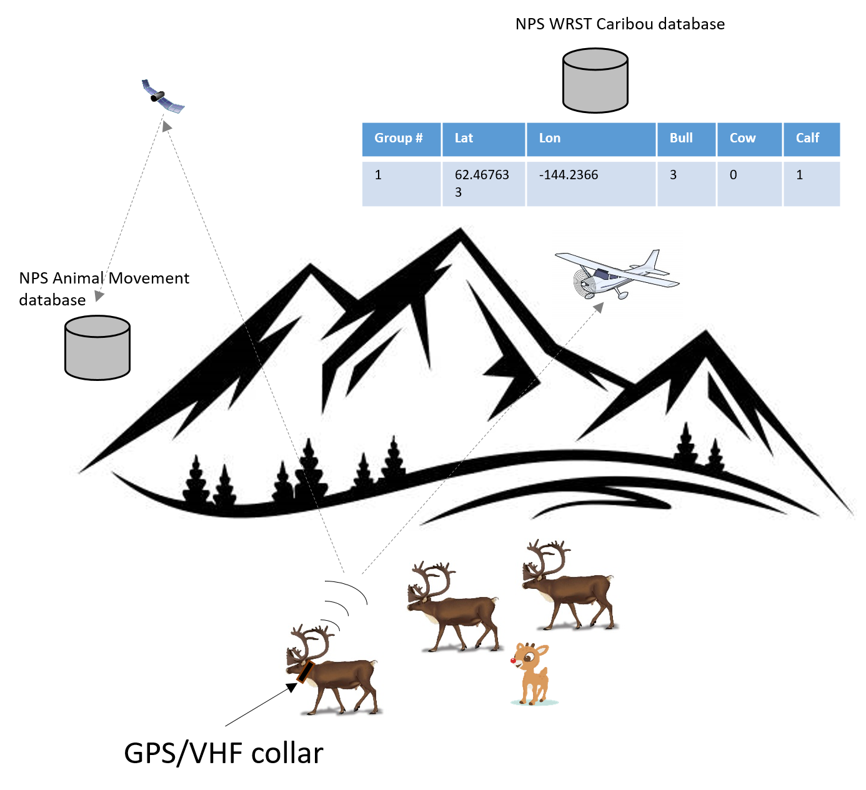

# Data entities

Biologists collect information about the Mentasta and Chisana caribou herds. Components of the collected information are stored in two databases depending on the content.

|  |  |  |
| --- | --- | --- |
| **Information** | **WRST Caribou database** | **Animal Movement database** |
| Animal capture | X |  |
| GPS/VHF collar management |  | X |
| Spatial GPS movements monitoring |  | X |
| Aerial surveys   * + Composition count   + Population estimate   + Radiotracking | X |  |

Data is matched and synchronized between the databases using a consistent Animal ID

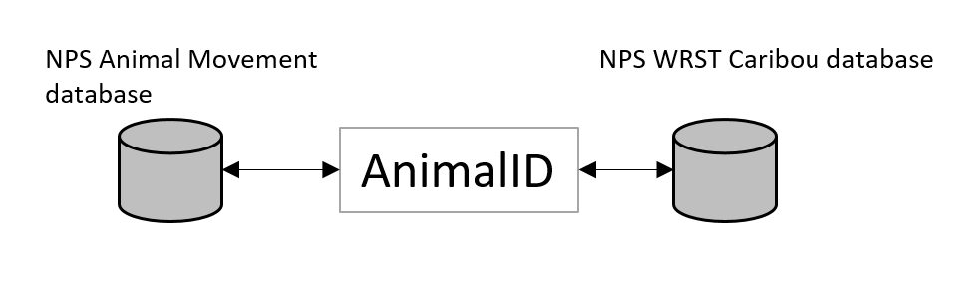

# WRST Caribou Monitoring Database Application architecture

Park managers rely on quantitative information for decision making. Scientists provide this information by collecting and analyzing data. These data are stored in databases. WRST Caribou monitoring data is actually managed in two databases. The spatial portion of the dataset is managed in the NPS Alaska Region's Animal Movement database. Herd population abundance and composition data is stored in the CAKN's WRST_Caribou database. The WRST Caribou Monitoring Database Application unites the two datasets in a single application to ease data entry and processing and to provide a framework for consistent data analysis and reporting. Together the databases and application comprise the WRST caribou monitoring data management system.

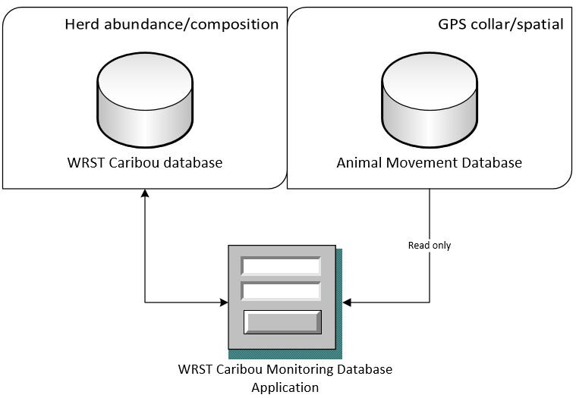

The back end database uses a Microsoft SQL Server and the front end application is built in Microsoft Visual Basic .NET.

# Data management life cycle

The WCMDA focuses on animal capture and aerial survey data. Data from the surveys is entered into the database directly or assembled into spreadsheets and then imported. Both the database and the application perform some automated quality control checks. Other checks must be done by a trained biologist. Once quality of the data is as high as possible and all defects are documented the WRST biologist certifies the dataset and it can then be analyzed.

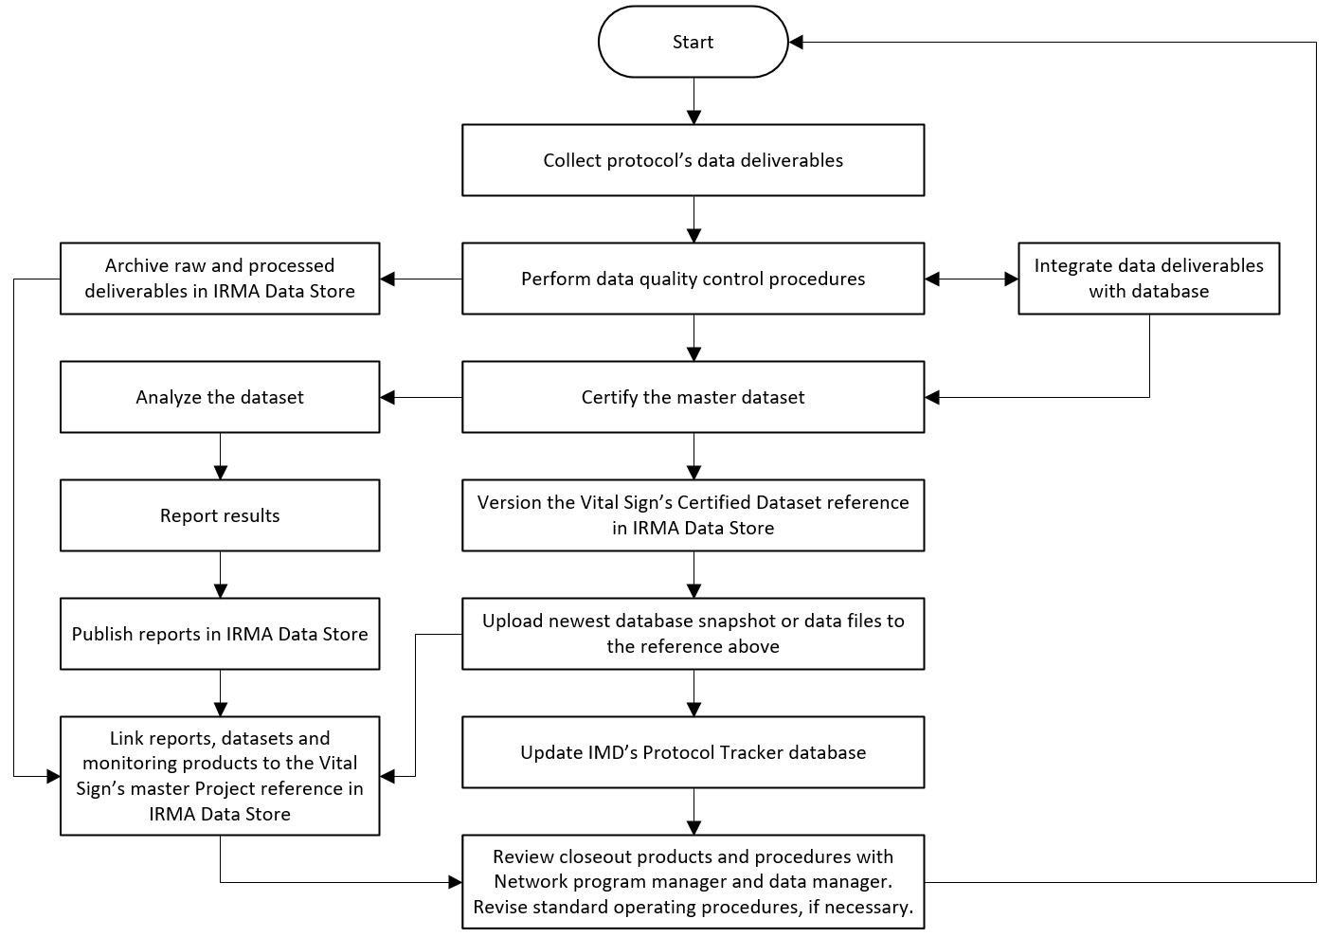

# Data Model

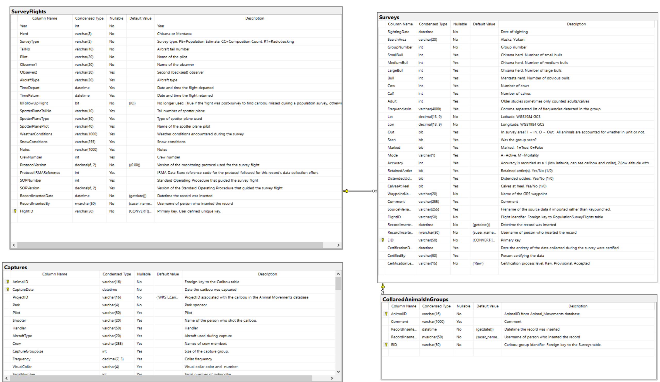

*Created with the Personal Edition of HelpNDoc:* [*Create help files for the Qt Help Framework*](https://www.helpndoc.com/feature-tour/create-help-files-for-the-qt-help-framework)

**Overview of interface**

An overview of the WRST Caribou Monitoring Database Application appears below.

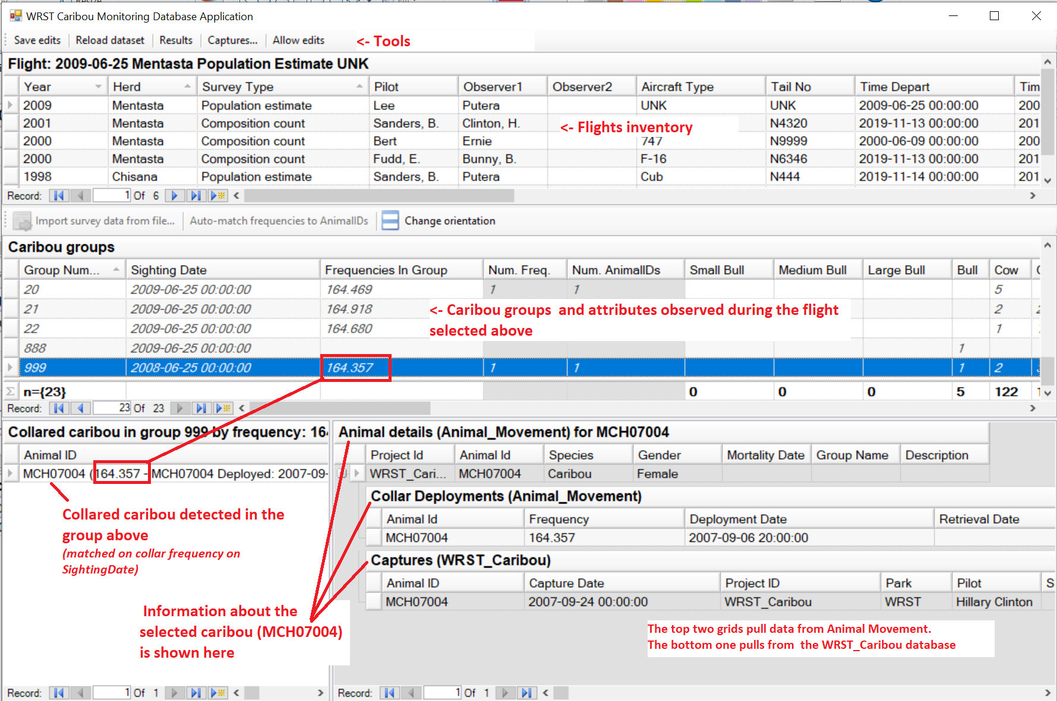

*Created with the Personal Edition of HelpNDoc:* [*Free Qt Help documentation generator*](https://www.helpndoc.com)

**Data entry: Survey data**

# Entering data

Data entry consists of three main tasks:

1. Enter details about a survey flight
2. Enter or import caribou group waypoint and group composition data
3. Match GPS collared animals to Animal Movement database

# Enter details about a survey flight

1. Start the application
2. The application starts in Read-only mode. Click the Allow edits button, top left, to start editing.
3. 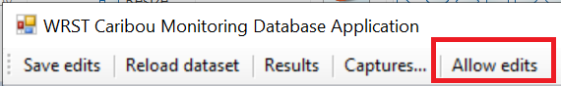
4. Enter flight details into the Flights grid (See Appendix A: Data definitions for details about each field).
5. 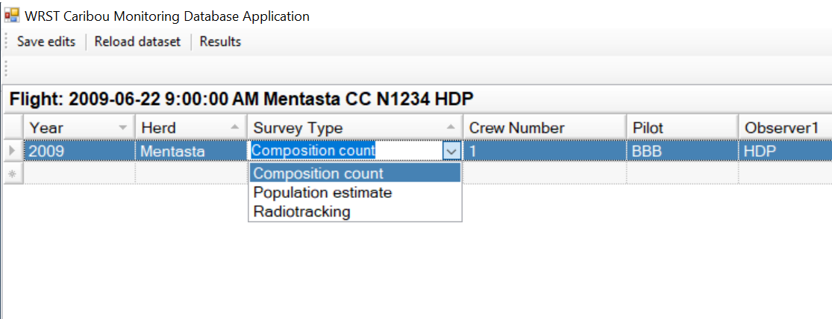
6. Ensure all required data is entered.
7. Save the record

# Enter caribou groups

Caribou groups are spatial points recorded during survey flights where caribou groups were spotted. To enter caribou groups you must first select the flight from which the group was observed, or enter a new flight to serve as the parent record.

## Enter caribou groups manually

1. Start the application
2. Enter a new flight record or select an existing flight record. The group(s) you enter must be associated with a flight.
3. Enter the group data in the Caribou Groups grid (See Appendix A: Data definitions for details about each field).
4. 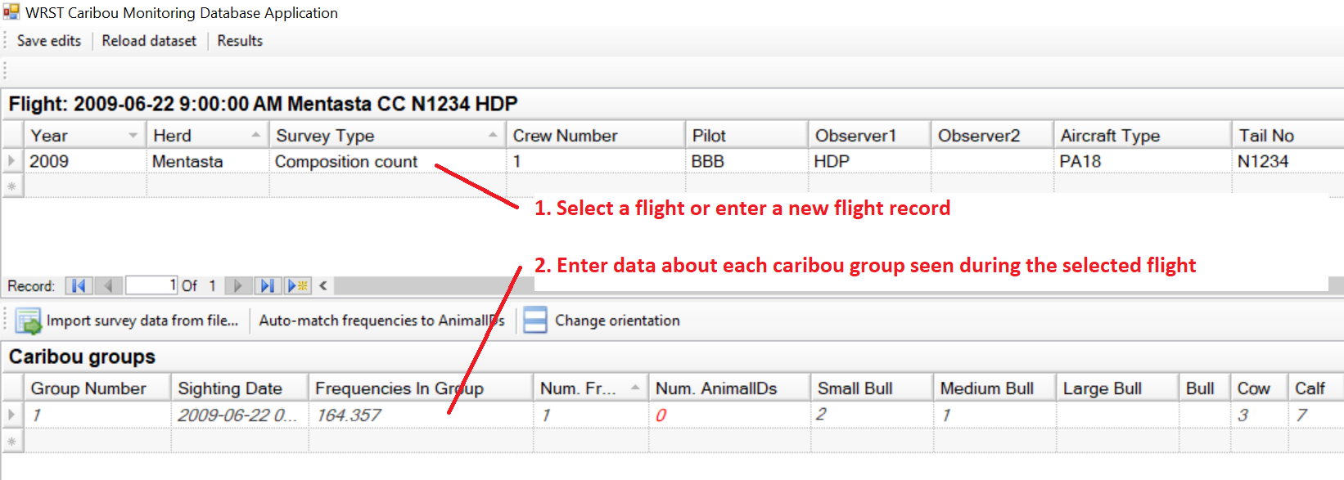

### Import caribou groups from a file

You may import caribou group data from a comma separated values (csv) text file or Excel spreadsheet. The spreadsheet must contain minimally the all the required data.

1. Start the application
2. Enter a new flight record or select an existing flight record. The group(s) you enter must be associated with a flight.
3. Click the Import survey data from file... button.
4. Navigate to the file to import
5. The Import data form appears
6. 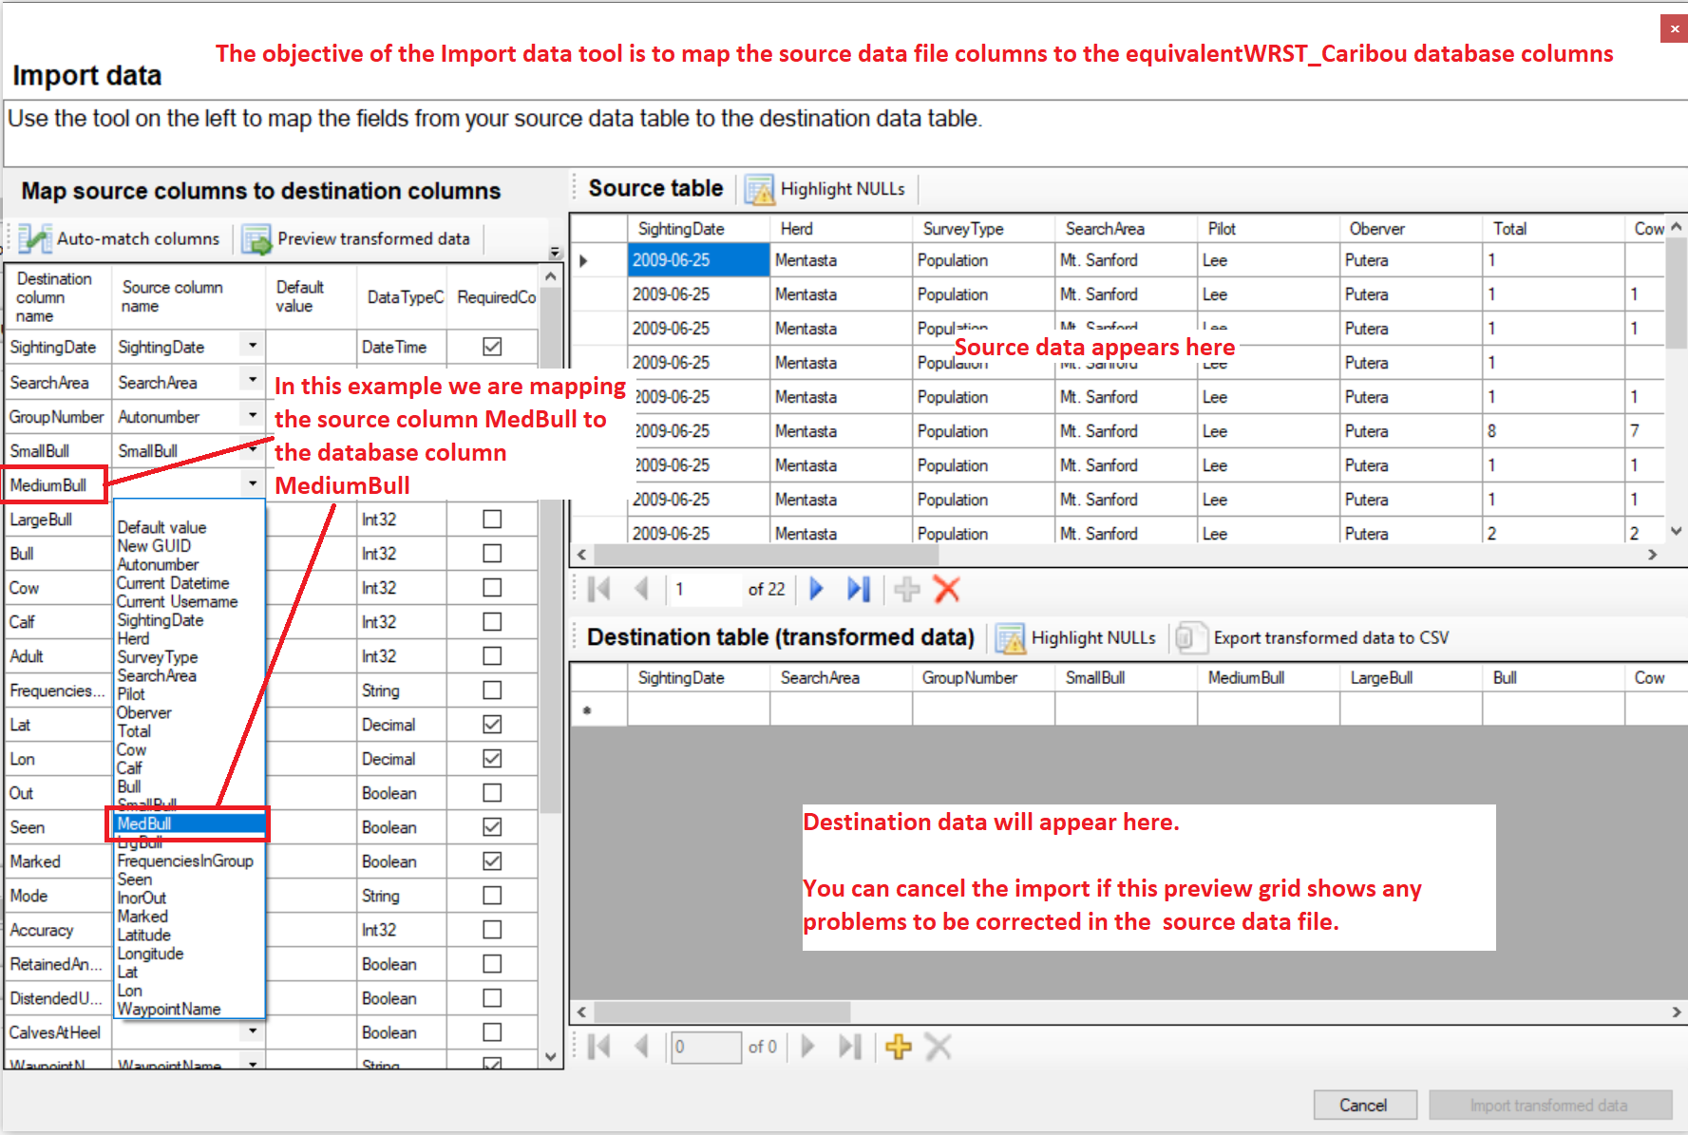
7. The source data will appear in the Source table grid. Ensure it is as expected.
8. Use the Map source columns to destination columns grid on the left to map data source columns to database destination columns.
9. When all required columns have been matched click Preview transformed data. Review that the source data has mapped to the database schema correctly. Correct any errors and preview again. You may cancel the import by clicking Cancel or closing the form. Click Import transformed data to bring the imported data into the main form.
10. The source data is now mapped and imported to the database application
11. 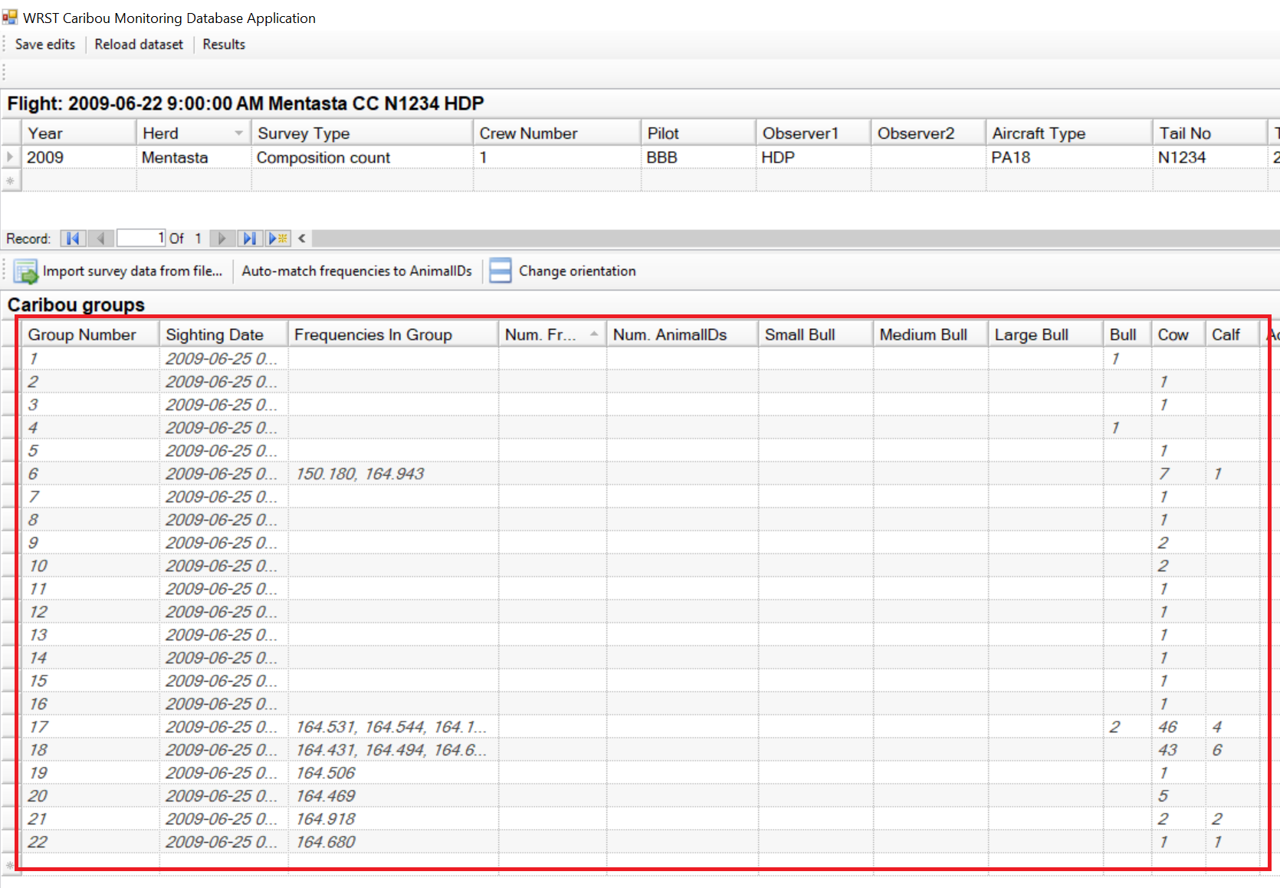
12. Save the dataset.

## Hints, Tips and Tricks

The Import data tool has a number of features to ease and simplify the process of importing data

### Auto-match columns

If the column names are the same you can click the Auto-match columns button. The tool will automatically match any similar column names. Auto-match correctly matched the first four columns in the example screenshot above. It did not match MediumBull to the source column MedBull because they are spelled differently.

### Default values

If a column is required but there is no matching column in the source file you may opt to add a Default value. The source data may not have a column for Observer, for example, but if you know that the Observer was named Elmer Fudd you may enter that name in the Default value column and the tool will populate the destination grid with that name. In another example the source data file may not have a value for Out but you know that all the sightings were in the search area. You may enter FALSE into the Default value field for the Out column and it will propagate that value to the destination data table.

### Generated values

Other default values include:

#### New GUID

Use this where a unique text key is required. A GUID may be used for any required field in the WRST_Caribou database with 'ID' in the column name; FlightID, EID, etc.

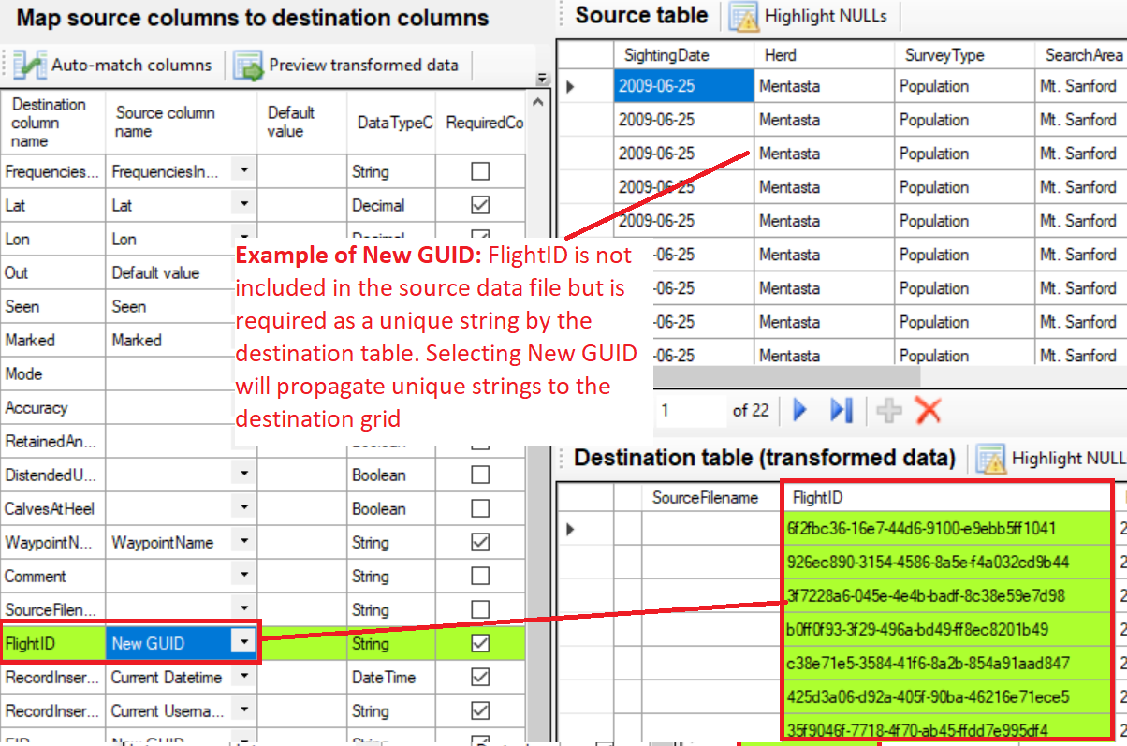

#### Autonumber

Autonumber is useful for required items that must be unique; GroupNumber for example, and will simply supply increasing integer values to the destination grid starting with 1.

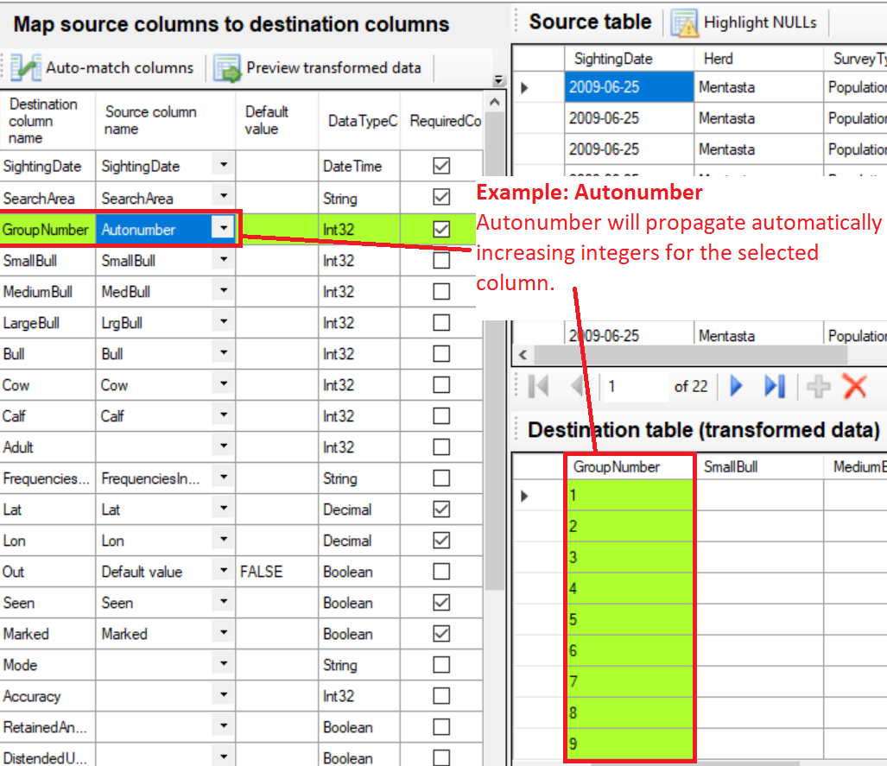

#### Current DateTime

Use this for metadata columns such as RecordInsertedDate.

#### Current Username

Use this for metadata columns such as RecordInsertedBy

## Match GPS collared animals to Animal Movement database

Caribou groups seen during aerial surveys may contain animals wearing GPS collars. Information about collared animals (details of the animal, collars, collar deployments and historical spatial locations) is stored in the NPS Alaska Region's Animal Movements database. It is important to match animals detected during surveys by frequency to animals in the Animal Movement database.

1. Start the application
2. Enter a new flight record or select an existing flight record. The group(s) you enter must be associated with a flight.
3. Enter a new caribou group Caribou Groups grid or select an existing group containing at least one FrequencyInGroup.
4. Using the AnimalID drop down tool in the Frequencies detected in group... grid select the animal on which the collar was deployed at the time of the sighting (basically match the frequency with the same item in the dropdown).
5. 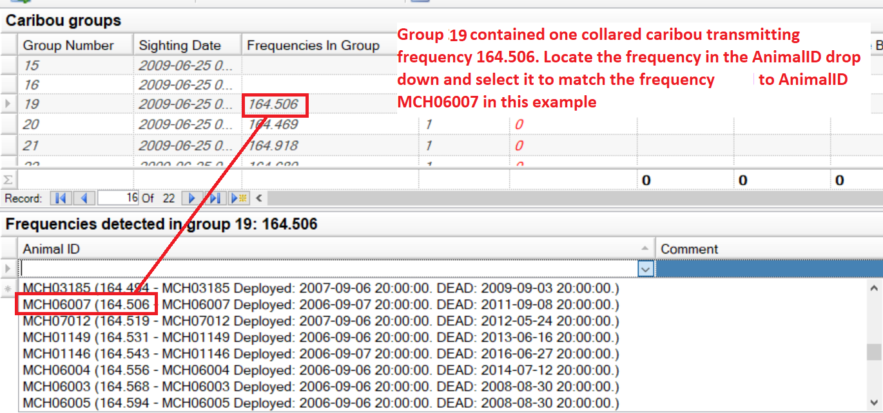

*Created with the Personal Edition of HelpNDoc:* [*Create help files for the Qt Help Framework*](https://www.helpndoc.com/feature-tour/create-help-files-for-the-qt-help-framework)

**Data entry: Capture data**

Enter caribou capture data into the Captures form.

# Procedure:

1. Start the application
2. Click the Captures... button
3. 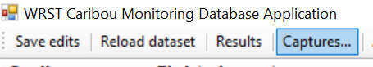
4. The Captures form appears
5. 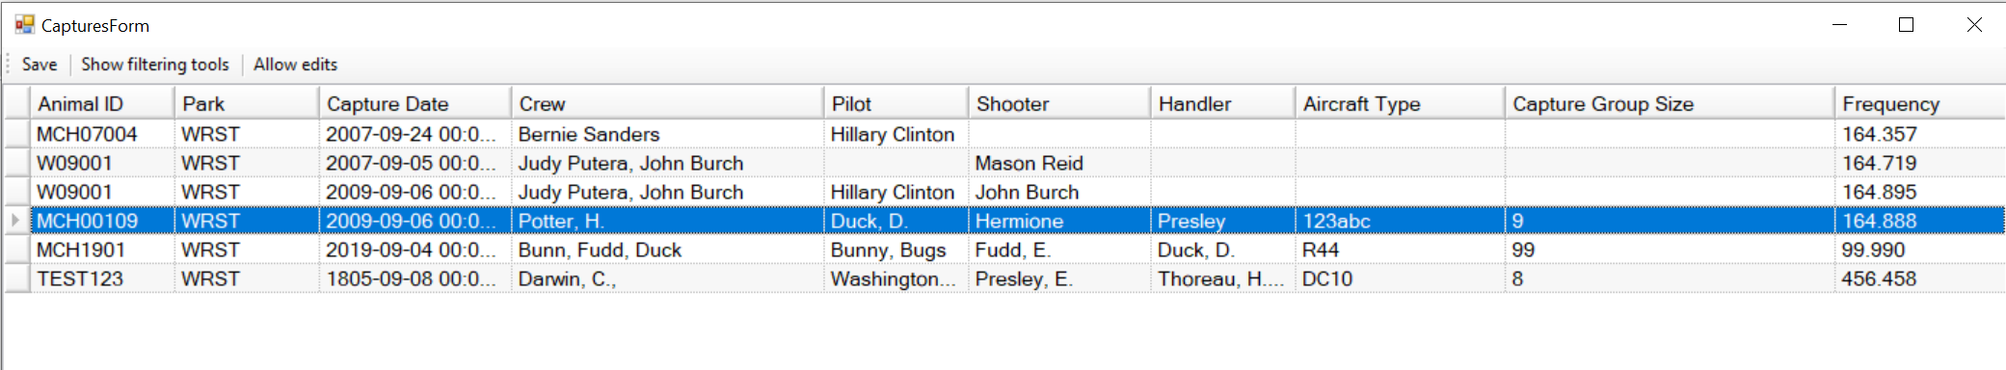
6. The form starts in Read-only mode. Click Allow edits to edit the captures dataset
7. 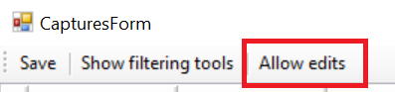
8. The application starts in Read-only mode. Click the Allow edits button, top left, to start editing.
9. Click Save edits to save your edits.

*Created with the Personal Edition of HelpNDoc:* [*Full-featured Help generator*](https://www.helpndoc.com/feature-tour)

**Quality control**

# Quality control

The WRST_Caribou SQL Server database and the WRST Caribou Monitoring Database Application have a number of quality control tools you can use to assure high quality data.

THIS PAGE IS DRAFT Feb, 2020

## Get an inventory of available Animals/GPS collar frequencies for a certain date

To get a list of animals/GPS collar frequencies that were available on a certain date run the spGetAnimalsInventoryOnDate stored procedure submitting the date for which you would like an inventory.

1. Open Sql Server Management Studio
2. Connect to the CAKN I&M Sql Server (contact the Network data manager for the server connection information)
3. Issue the following SQL substituting your own date

use WRST_Caribou

exec spGetAnimalsInventoryOnDate '2018-09-01'

Alternatively, navigate to the stored procedure as below and right-click it

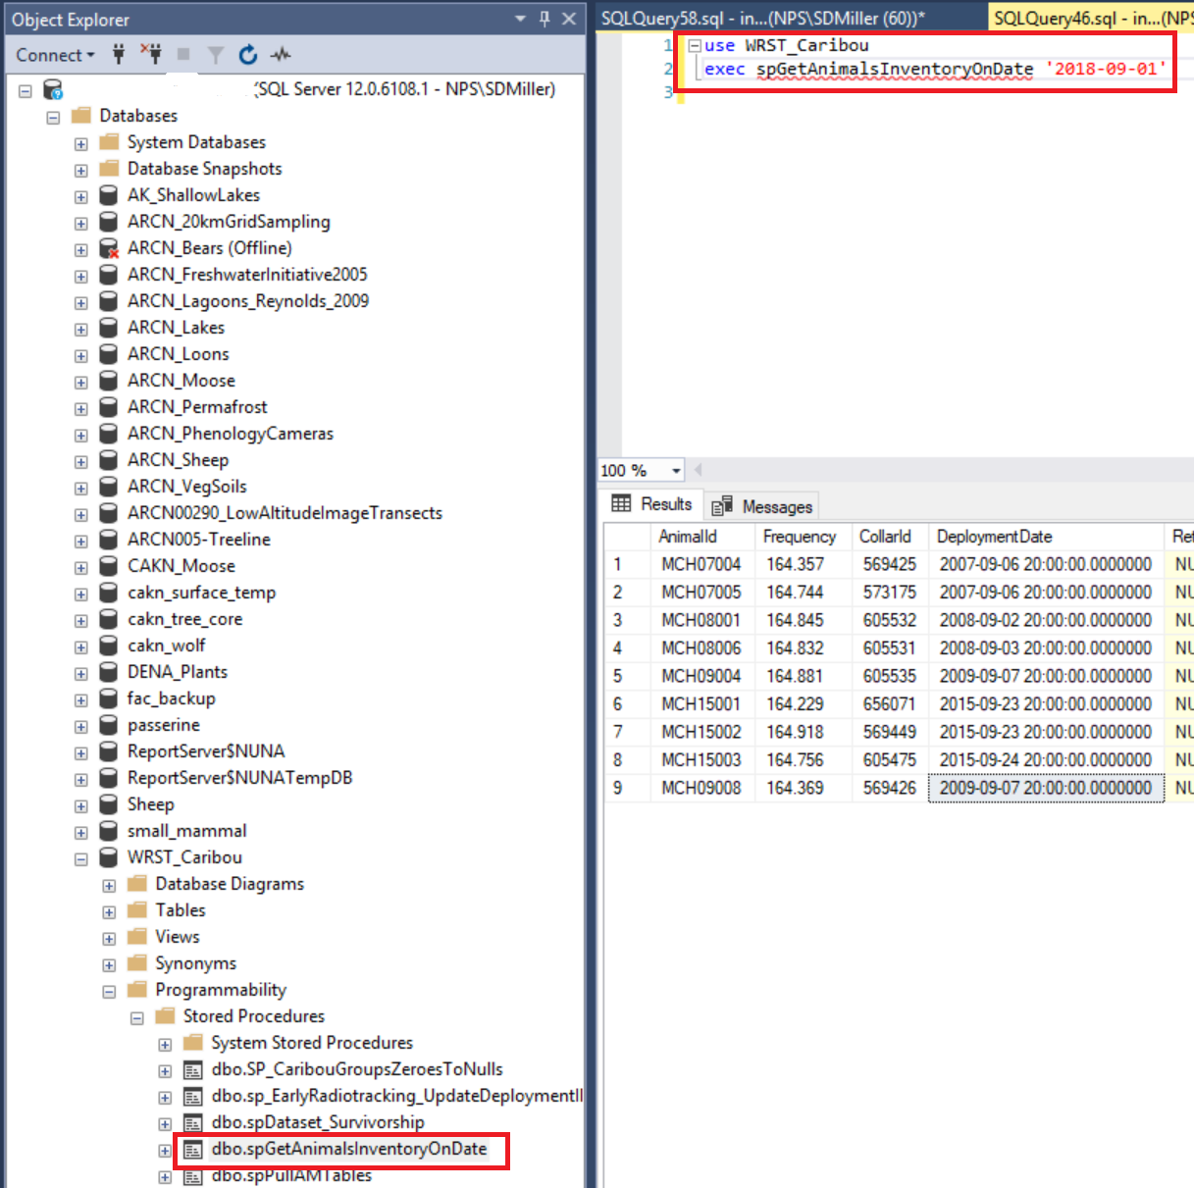

A dialog appears in which you can enter a date

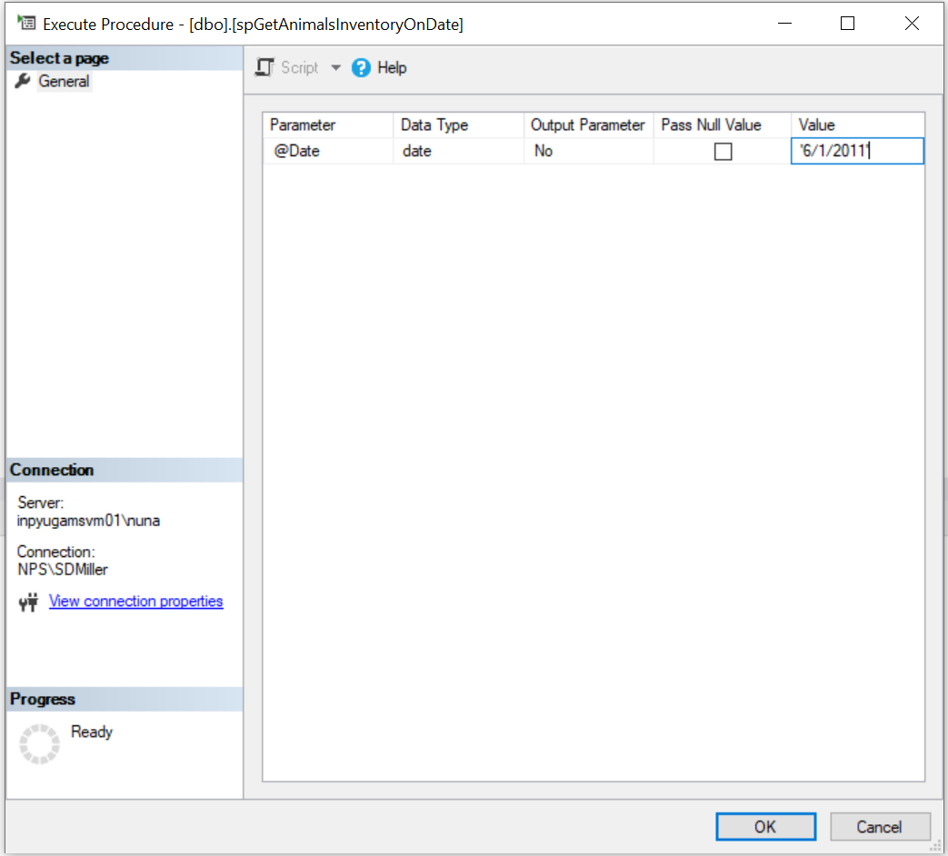

Click OK and the inventory should appear.

*Created with the Personal Edition of HelpNDoc:* [*Easily create CHM Help documents*](https://www.helpndoc.com/feature-tour)

**Appendix A: Data definitions**

# Data definitions

Database column definitions appear below. These definitions can be retrieved from the WRST_Caribou database by executing the DatabaseColumnsDescriptions view.

|  |  |  |
| --- | --- | --- |
| Table | Column | ColumnDescription |
| Captures | AdditionalDrugs | Additional drugs |
| Captures | Anesthetic | Immobilizing anesthetic. Carfentanil, Thiafentanil |
| Captures | AnestheticConcentration_mg_ml | Concentration of anesthetic (mg/ml) |
| Captures | AnestheticDosage_mg | mg of anesthetic (per dart) |
| Captures | AnestheticDosage_ml | ml of anesthetic (per dart) |
| Captures | AnestheticReversal | Drug used to reverse effects of anesthetic |
| Captures | AnestheticReversalConcentration_mg_ml | Concentration of anesthetic reversal in mg/ml |
| Captures | AnestheticReversalDosage_mg | mg of anesthetic reversal |
| Captures | AnestheticReversalDosage_ml | ml of anesthetic reversal given |
| Captures | AnestheticReversalRoute | Route of anesthetic reversal dose (IV, SQ, IM) |
| Captures | AnestheticReversalTime | Time (24hr) anesthetic reversal administered |
| Captures | AnimalID | Foreign key to the Caribou table |
| Captures | BloodSampleGreen | Plasma |
| Captures | BloodSamplePurple | Whole blood |
| Captures | BloodSampleRed | Serum |
| Captures | BodyCondition | Fat, Good, Poor, Emaciated |
| Captures | BodyLength | Body length in centimeters |
| Captures | CaptureDate | Date the caribou was captured |
| Captures | CaptureID | Primary key |
| Captures | CaptureLatitude | Latitude where the caribou was captured (Decimal degrees. Geographic coordinates, WGS84 datum). |
| Captures | CaptureLongitude | Longitude where the caribou was captured (Decmial degrees. Geographic coordinates, WGS84 datum). |
| Captures | CertificationDate | Date the entirety of the data collected during the survey were certified |
| Captures | CertificationLevel | Certification process level. Raw, Provisional, Accepted |
| Captures | CertifiedBy | Person certifying the data |
| Captures | ChestGirth | Chest girth in centimeters |
| Captures | Comments | Comments |
| Captures | Crew | Names of crew members |
| Captures | DartLocation | Description of where the dart hit |
| Captures | DrugEffect | 1-5 (Light --> Heavy |
| Captures | EstimatedAge | Estimated age based on tooth wear |
| Captures | FinalBodyTemperature | Final body temperature (Centigrade) |
| Captures | FinalBodyTemperatureTime | Final body temperature time (24hr) |
| Captures | Frequency | Collar frequency |
| Captures | GeneralLocation | General location |
| Captures | HindfootLength | Hindfoot measurement in centimeters. |
| Captures | InitialBodyTemp | Initial body temperature (Centigrade) |
| Captures | InitialBodyTempTime | Initial body temperature time (24hr) |
| Captures | Jaw | Jaw length in centimeters. |
| Captures | Lactating | Was the caribou lactating? True/False |
| Captures | MetatarsusLength | Metatarsus measurement in centimeters |
| Captures | NeckCircumference | Neck circumference in centimeters |
| Captures | NumHits | Number of dart hits |
| Captures | NumMisses | Number of dart misses |
| Captures | OldFrequency | Former frequency |
| Captures | OldVisualCollar | Former visual collar code |
| Captures | ProjectID | ProjectID associated with the caribou in the Animal Movements database |
| Captures | ProtocolIRMAReference | IRMA Data Store reference code for the protocol followed for this record's data collection effort. |
| Captures | ProtocolVersion | Version of the monitoring protocol used for the survey flight |
| Captures | RecordInsertedBy | Username of person who inserted the record |
| Captures | RecordInsertedDate | Datetime the record was inserted |
| Captures | Sedative | Sedative given during immobilization |
| Captures | SedativeConcentration_mg_ml | Concentration of sedative (mg/ml) |
| Captures | SedativeDosage_mg | Mg of sedative (per dart) |
| Captures | SedativeDosage_ml | ml of sedative (per dart) |
| Captures | SedativeReversal | Drug used to reverse effects of sedative |
| Captures | SedativeReversalConcentration_mg_ml | Concentration of sedative reversal in mg/ml |
| Captures | SedativeReversalDosage_mg | mg of sedative reversal |
| Captures | SedativeReversalDosage_ml | ml of sedative reversal given |
| Captures | SedativeReversalRoute | Route of sedative reversal dose (IV, SQ, IM) |
| Captures | SedativeReversalTime | Time (24hr) sedative reversal given |
| Captures | SerialNumber | Serial number of radiocollar |
| Captures | Sex | Sex. M/F |
| Captures | Shooter | Name of the person who shot the caribou. |
| Captures | SOPNumber | Standard Operating Procedure that guided the survey flight |
| Captures | SOPVersion | Version of the Standard Operating Procedure that guided the survey flight |
| Captures | TimeAnimalDown | Time animal subdued (24hr time format). |
| Captures | TimeFirstHitBounce | Time of the first hit/bounce (24hr time format). |
| Captures | TimeMobile | Time (24hr) caribou became mobile |
| Captures | TimeSecordHitBounce | Time of the second hit/bounce (24hr time format). |
| Captures | TimeStanding | Time (24hr) caribou stood up. |
| Captures | TimeStartChase | Start of the chase (24hr time format). |
| Captures | TimeThirdHitBounce | Time of the third hit/bounce (24hr time format). |
| Captures | TimeVisibleEffect | Time of first visible effect (24hr time format). |
| Captures | TS | Timestamp. Access front-end needs this to avoid write conflict errors. No other purpose. |
| Captures | VisualCollar | Visual collar color and number. |
| Captures | Weight_Kg | Weight in kilograms |
| Captures | WithCalf | Was the caribou with a calf? True/False. |
| CollaredAnimalsInGroups | AnimalID | AnimalID from Animal_Movements database |
| CollaredAnimalsInGroups | Comment | Comment |
| CollaredAnimalsInGroups | EID | Caribou group identifier. Foreign key to the Surveys table. |
| CollaredAnimalsInGroups | RecordInsertedBy | Username of person who inserted the record |
| CollaredAnimalsInGroups | RecordInsertedDate | Datetime the record was inserted |
| SurveyFlights | AircraftType | Aircraft type |
| SurveyFlights | CrewNumber | Crew number |
| SurveyFlights | FlightID | Primary key. User defined unique key. |
| SurveyFlights | Herd | Chisana or Mentasta |
| SurveyFlights | IsFollowUpFlight | True if the flight was post-survey to find caribou missed during a population survey, otherwise False. |
| SurveyFlights | Notes | Notes |
| SurveyFlights | Observer1 | Name of the observer |
| SurveyFlights | Observer2 | Second (backseat) observer |
| SurveyFlights | Pilot | Name of the pilot |
| SurveyFlights | RecordInsertedBy | Username of person who inserted the record |
| SurveyFlights | RecordInsertedDate | Datetime the record was inserted |
| SurveyFlights | SnowConditions | Snow conditions |
| SurveyFlights | SOPNumber | Standard Operating Procedure that guided the survey flight |
| SurveyFlights | SOPVersion | Version of the Standard Operating Procedure that guided the survey flight |
| SurveyFlights | SpotterPlanePilot | Name of the spotter plane pilot |
| SurveyFlights | SpotterPlaneTailNo | Tail number of spotter plane |
| SurveyFlights | SpotterPlaneType | Type of spotter plane used |
| SurveyFlights | SurveyType | Survey type. PE=Population Estimate, CC=Composition Count, RT=Radiotracking |
| SurveyFlights | TailNo | Aircraft tail number |
| SurveyFlights | TimeDepart | Date and time the flight departed |
| SurveyFlights | TimeReturn | Date and time the flight returned |
| SurveyFlights | TS | Timestamp. Access front-end needs this to avoid write conflict errors. No other purpose. |
| SurveyFlights | WeatherConditions | Weather conditions encountered during the survey |
| SurveyFlights | Year | Year |
| Surveys | Accuracy | NULL |
| Surveys | Adult | Older studies sometimes only counted adults/calves |
| Surveys | Bull | Mentasta herd. Number of obvious bulls. |
| Surveys | Calf | Number of calves |
| Surveys | CalvesAtHeel | Calves at heel. Yes/No (1/0) |
| Surveys | CertificationDate | Date the entirety of the data collected during the survey were certified |
| Surveys | CertificationLevel | Certification process level. Raw, Provisional, Accepted |
| Surveys | CertifiedBy | Person certifying the data |
| Surveys | Comment | Comment |
| Surveys | Cow | Number of cows |
| Surveys | DistendedUdders | Distended udders. Yes/No (1/0) |
| Surveys | EID | Primary key |
| Surveys | FlightID | Flight identifier. Foreign key to PopulationSurveyFlights table |
| Surveys | FrequenciesInGroup | Comma separated list of frequencies detected in the group. |
| Surveys | GroupNumber | Group number |
| Surveys | LargeBull | Chisana herd. Number of large bulls |
| Surveys | Lat | Latitude. WGS1984 GCS |
| Surveys | Lon | Longitude. WGS1984 GCS |
| Surveys | Marked | Marked. 1=True, 0=False |
| Surveys | MediumBull | Chisana herd. Number of medium bulls |
| Surveys | Mode | NULL |
| Surveys | Out | In survey area? I = In, O = Out. All animals are accounted for whether in unit or not. |
| Surveys | RecordInsertedBy | Username of person who inserted the record |
| Surveys | RecordInsertedDate | Datetime the record was inserted |
| Surveys | RetainedAntler | Retained antler(s). Yes/No (1/0) |
| Surveys | SearchArea | Alaska, Yukon |
| Surveys | Seen | Was the group seen? |
| Surveys | SightingDate | Date of sighting |
| Surveys | SmallBull | Chisana herd. Number of small bulls |
| Surveys | SourceFilename | Filename of the source data if imported rather than keypunched. |
| Surveys | TS | Timestamp. Access front-end needs this to avoid write conflict errors. No other purpose. |
| Surveys | WaypointName | Name of the GPS waypoint |
| sysdiagrams | definition | NULL |
| sysdiagrams | diagram_id | NULL |
| sysdiagrams | name | NULL |
| sysdiagrams | principal_id | NULL |
| sysdiagrams | version | NULL |

*Created with the Personal Edition of HelpNDoc:* [*Easily create Help documents*](https://www.helpndoc.com/feature-tour)

**Results**

# Opening the Results form

Data summaries and basic analyses are available through the Results form. To open the form:

1. Start the application
2. Click the Results button at the top of the form

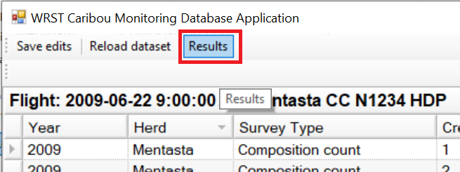

# Viewing data, queries and summaries

Data is summarized by the database through queries. Database queries are developed to answer particular questions, but all queries are available through the Results form. Simply select the query you would like to view and it will appear in the main query grid. The example below shows the results of a composition count survey:

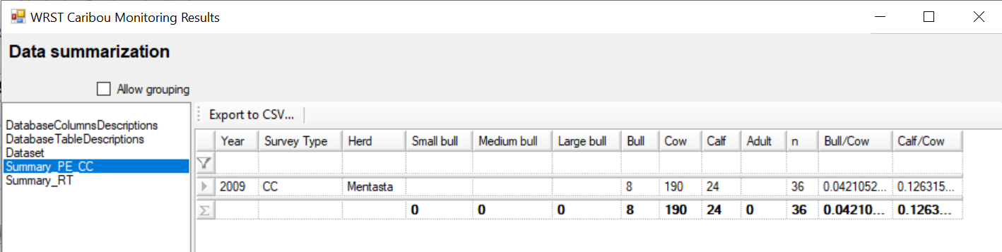

*Created with the Personal Edition of HelpNDoc:* [*Easy EBook and documentation generator*](https://www.helpndoc.com)